Supplier Name |  | Date: | 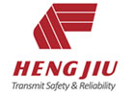
Contact Name
Street |  | P.O. Box
Town / Postcode |  | Telephone
Country |  | Fax
Internet address | http://www.
Official Contacts
 | Name | Tel. | Fax | E-Mail | No. of employees
Managing Director
Quality Manager
Technical Planning
Sales

 | Last year | 2 years ago | 3 years ago
Total Turnover
Current Product Range
Product Range | Product Descriptions

Main advantage & Business Case.
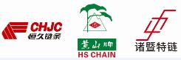
ZHEJIANG HENGJIU MACHINERY GROUP CO.,LTD.
No.8 Yingbin Road of Zhuji City, Zhejiang Province,China.
Tel:0086-575-87219928,Fax:575-87214388
E-mail: info@hengjiu-pt.com, www.hengjiu-pt.com

